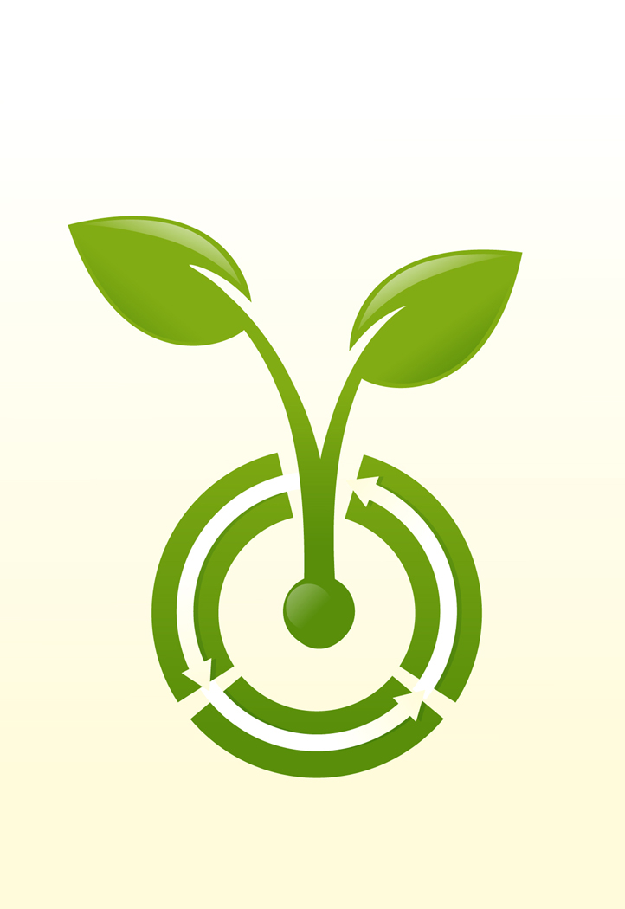
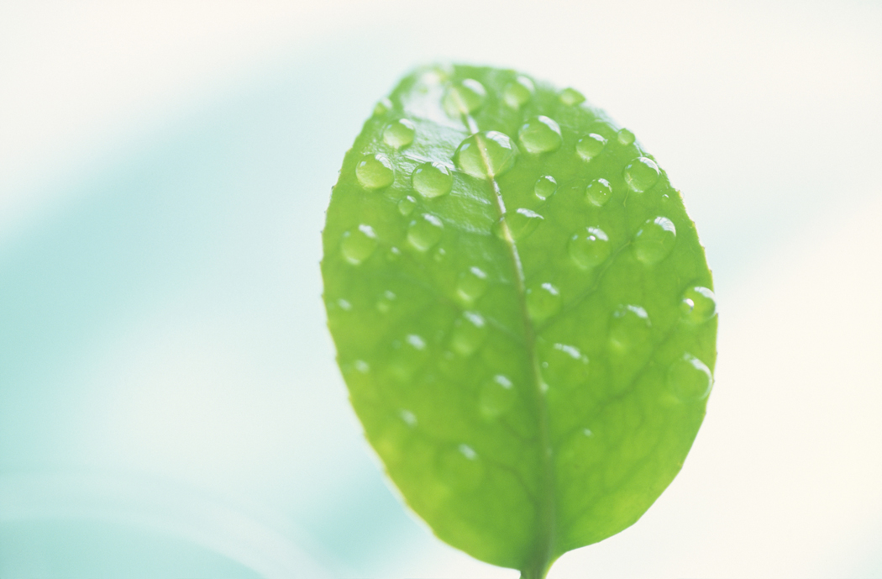
Photosynthesis Webquest
Honors Biology

Go to the following site.
http://www.phschool.com/science/biology_place/biocoach/index.html

Concept One
Write the equation for photosynthesis.

Explain how photosynthesis is an example of an oxidation-reduction reaction.

Concept Two
Write out the electromagnetic spectrum from shortest wavelength to longest wavelength.

What part of the spectrum can you see?

Record the colors of the visible light part of the spectrum from longest to shortest wavelength. Underline the first letter of each color.

Concept Three
Thomas Engelmann devised an experiment to learn which wavelengths (colors) of light were the most effective in carrying out photosynthesis. Explain his results.

Concepts Four, Five and Six
Label the appropriate diagram for each of the sections (please print the screen when you are done).

Concept Seven

What part of the visible light spectrum is absorbed by chlorophyll a?

What part of the visible light spectrum is reflected by chlorophyll a?

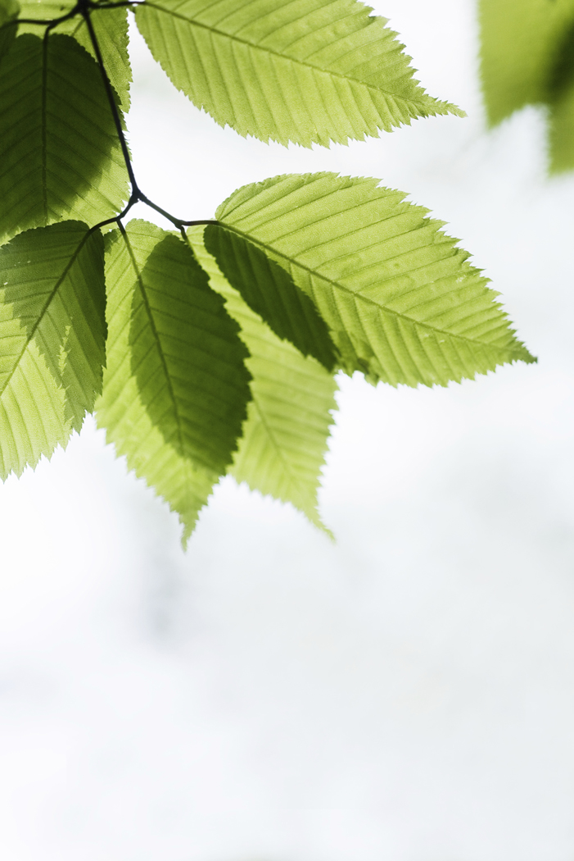

Concept Eight
Explain where the light dependent and Calvin Cycle each take place?

What is unique about each of those structures in terms of photosynthesis?

What is striking the thylakoids in the Light Reaction?

What is happening to water in the Light Reaction?

What two products produced in the Light Reaction are used in the Calvin Cycle?

During the Calvin Cycle what enters the reaction?

What is the final product of the Calvin Cycle

Directions: Fill in the arrows with the proper inputs, outputs and energy carrying compounds. Include the following terms in your summary: ATP, NADPH, carbon dioxide, water, light energy, oxygen, and carbohydrates.

1.
2.
7.
3.
5.
4.
6.
Light
Reaction
Dark
Reaction
Photosynthesis concept map

Directions: Use the following concepts to develop a concept map. You may add words to this list, but avoid using the same concept twice. Follow the rubric used for your enzyme concept map. Be sure to include visuals and links between your connections. Your map should be well organized and neat and have meaning connections.

Photons Pigments carotenoids chlorophyll
thylakoids stroma Chloroplast light-dependent reactions product light-independent sunlight
sun Photosynthesis ATP carbon dioxide
NADPH NADP⁺ Oxygen water
carbohydrate Visible light Calvin cycle
xanthophylls glucose reactant
wavelength energy electromagnetic spectrum

